Test Report

Report No.: | 1
Date of test: | June-11-2019, 15:19
Tester: | Vinod
Customer: | Netradyne
Standard: | ISO 7637-2 (2011-03)
Application: | 12 V system
Ambient Temperature: | 25.3
Humidity: | 46
Pressure: | 91 kPa
Comment: | Super Cap Board

T e s t R e s u l t
Result: | Device shut down after one minute

(Date) |  | (Sign)

T e s t P r o c e d u r e
Pulse Name: | ISO 7637-2 (2011-03) : 4.6.1 Pulse 1
Test generator: | UCS200N100 |  | Software No.: | 000731
 |  |  | Serial No.: | P14548168212
Coupling network: | UCS200N100 |  | Serial No.: | P14548168212
Va (Alternator): | 13.5 | V | Current limit: | 30 | A
Software: | iso.control |  | Version: | 5.4.3

T e s t S e t u p
 |  |  | 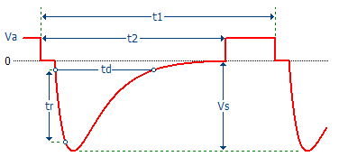
Vs: | -75 | V
t1: | 0.5 | s
t2: | 200.00 | ms
tr: | 1 | us
td: | 2000 | us
Ri: | 10 | Ohm
Coupling: | Battery
Events: | 500
Test duration: | 00:04:10 | h

T e s t R e s u l t
Pulses: | 500
Result: | Device shut down after one minute

